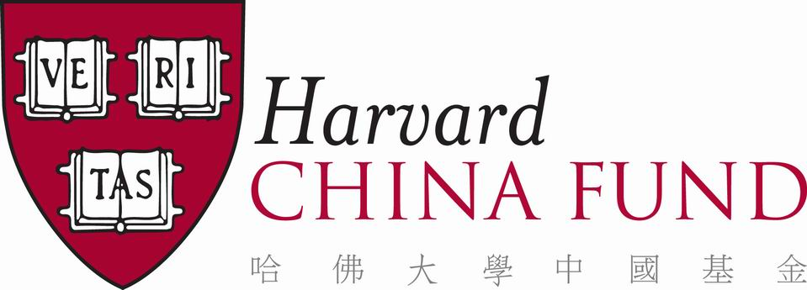

HARVARD CHINA STUDENT INTERNSHIP PROGRAM - SUMMER 2021

The Harvard China Student Internship Program (HCSIP) is offered in partnership with Chinese corporations, NGOs/NPOs, and multinational companies in China. Students experience modern China through their internship placements and gain an introduction to Chinese history and culture, all while learning first-hand about life in the workplace. The structure of the program includes a nine-week internship, a week-long field trip (not taking place in 2021), and numerous cultural events.

The 2021 iteration will continue with the hybrid model where interns physically located in Greater China may be able to participate in person where possible, and those who are not, will intern virtually with the assistance of web conferencing platforms and messaging apps of their host institutions' choice. Please note that the plan is subject to change due to the evolving COVID-19 pandemic situation. We urge you to consult Harvard’s official website regarding COVID-19 for the most recent travel guidance and healthcare resources.

The program is managed by the Harvard China Fund (HCF) staff in Shanghai and Cambridge.

Internship Period: June 14th to Friday, August 13th, 2021.

Eligibility: Returning undergraduates from all concentrations are eligible to apply. Chinese language is not required to apply, but almost all of the internship positions require some knowledge of oral and written Chinese. Students must have excellent written, communication, and analytical skills. Students must be able to commit to the entire 9-week program.

Funding: All interns will receive a Summer 2021 Special Support Grant of USD 4,000.

Internship Placement: Host institutions will be concentrated in Beijing, Shanghai, Shenzhen, Guangzhou, Hong Kong, and Taiwan. Interns will work at leading multinational and Chinese companies in various industries. Remote opportunities will be offered for summer 2021; some students may be able to participate in the above host cities depending on individual situations. Applicants should indicate the type of host organization or work they prefer, and their relevant experience and skills on the application form. While there is no guarantee that placements can be made with specific companies or in specific cities, every effort is made to ensure that students have a satisfying experience consistent with their interests.

Visit our website for a sample of host companies from last summer and potential host companies for summer 2021: http://hcf.fas.harvard.edu.

Application Deadlines: Students should submit a completed application by Friday, February 26, 2021 through CARAT. The Harvard China Fund will select candidates for interviews in early February. Students will be notified of their acceptance into the Internship Program by late April 2021.

2021 HARVARD CHINA STUDENT INTERNSHIP PROGRAM APPLICATION

Deadline: Friday, February 26, 2021

First Name: Last Name: Chinese Name (if any): ______________________________________________________________________________

Campus Address, Including House: ______________________________________________________________________________

Permanent Address: ______________________________________________________________________________

Concentration & Graduation Year: ______________________________________________________________________________

Phone: ____________________________ Date of Birth: ________________________________

E-mail: ____________________________ Harvard ID: _________________________________

Citizenship: ___________________________ Gender: _________________________________

Have you ever been to China (mainland China, Hong Kong, Taiwan) before? If so, mention purpose/year(s)/duration:
______________________________________________________________________________
______________________________________________________________________________
______________________________________________________________________________

Have you held an internship in China before? If so, when, and describe: ______________________________________________________________________________
______________________________________________________________________________
______________________________________________________________________________

Do you have any international travel experience? Please describe briefly:
______________________________________________________________________________
______________________________________________________________________________
______________________________________________________________________________

Have you participated in any other similar programs while studying at Harvard (internship, volunteer, Harvard Beijing Academy, etc.)? Please list below:
______________________________________________________________________________
______________________________________________________________________________
______________________________________________________________________________

- Internship industry / work preferences (please rank your top three preferences):

___ Accounting
___ Advertising and Design
___ Agribusiness and Food
___ Aviation
___ Biotech
___ Education
___ Environmental Issues

___ Finance / Investment
___ Foundation / NGO
___ Healthcare
___ Information Technology
___ Insurance
___ Management Consulting
___ Media
___ Manufacturing
___ Real Estate
___ Research
___ Retail
___ Tourism/Hospitality
___ Other ______________________

- Please describe your relevant skills for the industry / work preferences you selected in
Question 1.
______________________________________________________________________________
______________________________________________________________________________
______________________________________________________________________________
______________________________________________________________________________
______________________________________________________________________________

Language fluency

Please rate your spoken fluency in Mandarin Chinese (Putonghua)

0=No spoken language skills, 5=completely fluent/native speaker

_______________________________________________________________________

_______________________________________________________________________

  - Please rate your written Chinese language skills
0=No writing ability, 5=Fluent writing ability
_______________________________________________________________________
_______________________________________________________________________

Please list any additional pertinent skills (computer/IT, writing, communication, analytical, etc.),

including knowledge of other languages:
________________________________________________________________________________________________________________________________________________________________________________________________________________________________________________________________________________________________________________

- Why are you interested in HCSIP? What are your reasons for applying? Your expectations for this experience? Please elaborate in an attached essay – 2 page maximum.

Application materials to be submitted beyond this form:
  - Essay, from Question 5 (no more than two pages double spaced)
  - Harvard College transcript (unofficial)
  - Resumé (no more than one page)
  - Letter of recommendation (preferably from resident dean, professor or former employer)

Please submit this form and accompanying materials to us through CARAT. While all efforts should be made to submit the recommendation letter through CARAT, if your recommender is unable to access CARAT, please have them send their letter directly to Emmeline Liu at the address below, or by email to emmeline_liu@fas.harvard.edu. All materials must be submitted by Friday, February 26, 2021.

Harvard China Fund
CGIS South Building, Room S125
1730 Cambridge Street
Cambridge, MA 02138
Tel: 617.496.3982 / Fax: 617.495.9976
emmeline_liu@fas.harvard.edu
http://hcf.fas.harvard.edu

Applicant Signature: __________________________________________________________

Date: _______________________________________________________________________

